**A Review of Wireless Synchronization for UWB Systems**

1. Abstract

UWB technology has recently gained increasing acceptance in a variety of line systems. It benefits from a normally wide transmission signal band (as little as 50 MHz according to EU regulations [1] and 500 MHz according to FCC regulations [2]), which results in a short pulse duration that allows for forwarding of the received signal Precise timing checks data throughput and shields the system from multipath problems because pulses can be easily distinguished.

More importantly, the devices that enable UWB technology can be very powerful and cost-effective. All of this makes UWB technology an excellent candidate for positioning systems, mainly due to the strict regulations that enable the latest WiFi - or blue-tooth based systems to achieve up to/multi-centimeter positioning accuracy indoors.

A typical localized system architecture consists of tags and infrastructure including anchors and controls distributed around the advanced location area. Two architectures can be distinguished, unilateral, where tags are receivers, and anchor transmitters. Multilaterally, the opposite is true. For the system to work properly, all infrastructure clocks must be synchronized because precise timing is critical to location calculations. In our UWB positioning system implementation, for each time of doing TDOF calculation, the tag is the transmitter and the anchors are receivers. Noted that in our scheme, there are no difference of tags and anchors, which means every module will have chance to be a tag because we need to get the distance of each pair of nodes.

When it comes to clock synchronization, there are two major issues [3] :

· Device synchronization -- done between anchors to maintain the same time base,

· Drift compensation -- Temperature and environmental changes can lead to device clock drift to a microsecond.

There are many ways to solve the above problems, the simplest is to provide cable connections between all equipment. It is most common in commercial systems [4][5] However, the deployment of wired infrastructure in buildings or built-up areas may have problems. Therefore, it is often desirable to provide a wireless solution.

This article will introduce several methods to achieve wireless synchronization.

In [3], a method to realize wireless synchronization in a unilateral positioning system is introduced by the so-called regional regulator which periodically sends data packets that are received by the tag recording the receiving time, and the anchor which sends data packets in a constant delay order, which are received by the tag Time-related data are collected in the system controller, in which the position is calculated. A similar method is used in the EIGER system [6], with the main difference being that the position is calculated with the EIGER marker.

In a multilateral system, a reference tag placed at a fixed and known location can be synchronized. It periodically sends packets received by the anchor. Since the propagation time between the reference tag and the anchor is constant, packets arrive at the anchor in step [7][8][9].

In [10], The authors propose that a solution combining ToA and DoA (direction of arrival) measurements do not require synchronization because the system infrastructure consists of an anchor with an antenna array.

Another method is directly based on the pulse synchronization level. There is an algorithm that works at a lower system level. See [11].

1. System Architecture and Principles of Wireless Synchronization Using a Reference Module

First, we recall the method to do the WUB positioning: TDOA (Time difference of arrival).

TDOA positioning does not need to synchronize between base stations and mobile terminals, but only between base stations. Because base stations are fixed, it is much easier to synchronize between base stations and between base stations and mobile terminals. This makes TDOA positioning much easier to implement than TOA positioning, so TDOA positioning is widely used.

It can locate by measuring the transmission delay difference between two different base stations and mobile terminals. Assuming that the distance difference between the position of the mobile terminal and base stations 1 and 2 is R21=R2-R1, then the position of the mobile terminal must be on the hyperbola with the two base stations as the foci and the distance difference between the two focal points is constant R21. That is if the position of the mobile terminal is ($X_{0},Y_{0})$, the position of the base station 1 is ($X_{1},Y_{1})$, and the position of the base station 2 is ($X_{2},Y_{2})$, then they satisfy the relation:

$$R_{21}=R_{2}-R_{1}=\sqrt{{\left(X_{0}-X_{2}\right)}^{2}+{\left(Y_{0}-Y_{2}\right)}^{2}}+\sqrt{{(X_{0}-X_{1})}^{2}+{(Y_{0}-Y_{1})}^{2}}$$

Then another set of hyperbolas can be obtained through the TDOA of another set of mobile terminals and base station 1 base station 3 or base station 2 base station 3. The two sets of hyperbolas will produce at most two intersection points, and then the location of the mobile terminals can be determined according to prior knowledge (such as radius range, etc.).

Its basic principle can be well illustrated by the following picture:

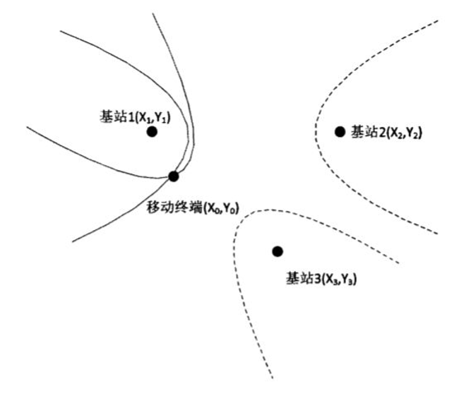

Figure 1. TDOA Method

The positioning system architecture developed in the NITICS project is shown in Figure 2. Anchor nodes measure time of arrival of packets transmitted by tags and the reference node. Results are send to the System controller over WiFi interface. The controller evaluates tag's position. The system implements TDOA positioning technique so the anchors synchronization is needed. The reference node distributes packets used for time synchronization and anchor's measurement errors reduction. Implementation of wireless synchronization and WiFi links simplified the solution. The anchors do not need wired links neither for synchronization nor results transfer.

Each device shown in Figure 2, in addition to the system controller, has a DW1000 core on the board [12]. It is an 802.15.4A-compliant UWB transceiver anchor node and tag equipped with DWM1000 module, integrated with DW1000 core crystal oscillator and antenna DW1000 cores combined with TCXO (temperature compensated crystal oscillator) are used because the reference nodes require better timing.

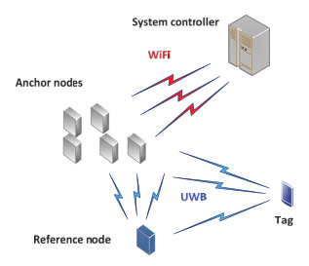

Figure 2. Localized System Architecture

There are two factors that have significant effects on positioning accuracy and accuracy: frequency stability and frequency tolerance. They both affect the time difference between arriving at the measurement. Results of period measurements of the system equipped with quartz crystals can illustrate the problem. The equipment measured to the TCXO-driven transmitter's packet transmission. The anchors were installed in the room in which windows were opened for a few minutes. The difference between the transmitted signal period and the anchor period measurement is shown in Figure 3.

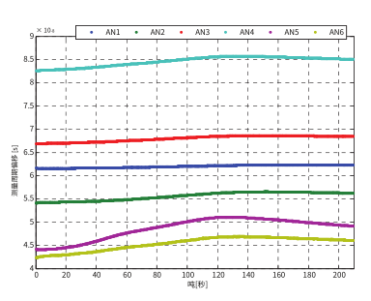

Figure 3. Transport in a positioning system

Although the DWM1000 module provides a way to adjust the clock frequency, the inexact correction of the cooling anchor (indoor-outdoor temperature proximity) leads to an increase in the measured offset. Depending on the position of the anchor, the observed error can severely limit the accuracy of the positioning system

Therefore, an error-reducing method is required. The method implemented in the system relies on the other nodes of the system transmitting packets at known reference intervals to measure the arrival time of packets and the correct measurement results

In the transmission plan of the system, as shown in Figure 4, the data packets initiated by tags arrive at the reference node and the anchor node (only two anchor points are considered in the figure). The reception of tag's packet trigger the timer in the reference node. After the DELAY of TD1, the node sends data packets (R1) and Tref in the reference period (R2) after repeated transmission after propagation delays T2 and T3, the signal from the reference node arrives at two anchor points

Anchors measure the time of arrival of all received packets, so they can calculate tm2, tm3, Tref2, and Tref3 periods. Two first results are used for TDOA calculation. Tref2 and Tref3 are used by the anchors for measured period correction (see Figure 4).

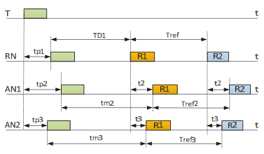

Figure 4. Process of Synchronized TDOA

The arrival time difference between AN1 and AN2 anchors is calculated according to the following formula:

TDOA21= TP3-TP2 = TM2-TM3 + T3-T2

The TM2 and TM3 intervals are both corrected versions of the intervals tm2m and tm3m directly measured by the anchor. The correction includes simple calculations:

Tm2 =tm2­m *(Tref/Tref N) (2)

Since the measurement error correction during the reference period will reduce the accuracy of the results, the typical moving average formula is filtered during the reference period:

Tref n =Tref n-1 (1-k) + k*Tref2 (3)

The current reference period value corrected by the results depends on the previous value and the measurement result of the current reference period (Tref2 in node AN1)

Overall, the idea of the scheme is that we use the reference module to turn different clock drifts to the clock of the reference module’s clock. So that we can synchronize the nodes that we need.

This method is the most suitable for our project. The hardware is similar to our project and it doesn’t need too much work to apply.

1. Other methods
   1. Joint distributed synchronization and positioning in UWB ad hoc networks using TOA

This method is a globally distributed solution for time synchronization and location in the network. On the one hand, the proposed synchronization scheme relies on cooperative bidirectional ranging/time of arrival transactions, and a diffusion algorithm is used to ensure that the clock parameters converge to the average reference value of each node. Although the described solution appears general-purpose at first glance, its sensitivity to time-of-arrival accuracy influences the selection of the ultra-wideband physical layer for pulsed radio in extraordinary contexts. On the other hand, the distributed algorithm combined with the synchronization scheme reduces the influence of non-line-of-sight ranging error on the positioning accuracy without increasing the protocol hook. More specifically, the realistic UWB ranging error model we use takes into account uWB channel effects, as well as detection noise and relative clock drift. Then, compared with the classical distribution-weighted least square method, it is proved that the cooperative distribution maximization method of distance estimation loglikelihood can reduce the uncertainty of the estimated position. Finally, by asynchronously approximating the positive gradient direction of the loglikelihood function, it is proved that the proposed distributed maximum loglikelihood algorithm maintains reasonable complexity at each node. For distributed synchronization and localization algorithms, the simulation results demonstrate the relativity of the proposed solution [13].

* 1. With the significant growth of people's interest in indoor location service (LBS), indoor location has attracted more and more attention. There are several different techniques for calculating the positions of objects and people in buildings. Methods using received signal strength measurements (such as WiFi or BLE based) are the most common, but provide an accuracy of about 2-3 meters. In recent years, ultra-wideband (UWB) technology has been increasingly considered for indoor positioning. It relies on a measurement of the arrival time of the received signal and allows the calculation of position with an error range of only tens of centimeters. However, to work properly, UWB-based systems require strict synchronization between the anchor points that make up the infrastructure. A new wireless synchronization method using two reference nodes is proposed. The synchronization method is described, the transmission scheme is explained, and the experimental verification results are discussed [14].
  2. Some schemes do not need synchronization, but these methods are not so suitable for our project.

1. Conclusion

In this report, we discussed several methods to achieve wireless synchronization. The most suitable solution contains the description of the method providing wireless anchors synchronization and reduction of measurement errors in the UWB positioning system. Wireless synchronization simplifies system installation. The proposed technique can be used in systems where anchors are equipped with low stability clock oscillators. Investigation of the method implemented in the system proved its efficiency. By averaging the results of reference period measurements precision of obtained results can be significantly improved.

REFERENCES

[1] COMMISSION DECISION 2009/343/EC of 21 April 2009 amending

Decision 2007/131/EC on allowing the use of the radio spectrum for

equipment using ultra-wideband technology in a harmonized manner in

the Community.

[2] FCC (GPO) Title 47, Section 15 of the Code of Federal Regulations

SubPart F: Ultra-wideband

[3] J.X Lee, Z.W. Lin, P.S. Chin and C.L. Law, “Non-synchronised time

difference of arrival localisation scheme with time drift compensation

capability” in IET Communications, Vol. 5, Issue 5, 2011, pp. 693-699

[4] https://www.zebra.com/us/en.html

[5] http://www.ubisense.net/en/

[6] J. Kolakowski, A. Consoli, V. Djaja-JoĞko, J. Ayadi and L. Morrigia,

“UWB Localization in EIGER Indoor/Outdoor Positioning System” in

Proceedings of 8th IEEE International Conference on Intelligent Data

Acquisition and Advanced Computing Systems: Technology and

Applications, vol. 1, 2015, pp. 845-849.

[7] C. McElroy, D. Neirynck and M. McLaughlin, “Comparison of wireless

clock synchronisation algorithms for indoor localisation systems” in

Proceedings of Communications Workshop Conference, IEEE 2014, pp.

157-162

[8] H. Matsumoto, H. Kusano, T. Morokuma and K. Sakamura, “Numerical

and experimental investigation of TDOA-based positioning system by

ultra-wideband impulse radio” in Proceedings of Wireless Sensors and

Sensor Networks Conference, IEEE 2011, pp. 25-28

[9] V. Djaja-JoĞko and J. Koáakowski, “UWB Positioning System for

Elderly Persons Monitoring” in Proceedings of TELFOR 2015, 2015,

pp. 169-172

[10] Z. Irahhauten, H. Nikookar and M. Klepper, “2D UWB Localization in

Indoor Multipath Environment Using a Join ToA/DoA Technique” in

Proceedings of Wireless Communications and Networking Conference,

IEEE 2012, pp. 2253-2257

[11] R. Akbar and E. Radoi, “An Overview of Synchronisation Algorithms

for IR-UWB Systems” in Proceedings of Computing, Networking and

Communications Conference, 2012, pp. 573-577

[12] DW1000 Data Sheet, DecaWave Ltd, Dublin, 2014

[13] B. Denis, J. -. Pierrot and C. Abou-Rjeily, "Joint distributed synchronization and positioning in UWB ad hoc networks using TOA," in IEEE Transactions on Microwave Theory and Techniques, vol. 54, no. 4, pp. 1896-1911, June 2006, doi: 10.1109/TMTT.2006.872082.

[14] V. Djaja-Josko, "Novel method for the wireless synchronization of the anchors in the UWB localization system utilizing two reference nodes," 2020 23rd International Microwave and Radar Conference (MIKON), 2020, pp. 69-73, doi: 10.23919/MIKON48703.2020.9253932.